

Landing page:

* NRF and DSI logos probably bottom left but we need to find out from Corp Comms
* Graphs are nice but where’s the ‘science’? need to find something that includes that with maybe being part of ‘Africa’
* Change: Visualize the research data your audience deserves to see to something like  
    
  African Science, Technology and Innovation Data
* Change: Welcome to ASTI portal. The most trusted source for collaboration research. To read  
    
  Welcome to the African Science, Technology and Innovation portal – African S&T landscape at your fingertips.
* I think the little logo for the portal should have a bit of Africa in it

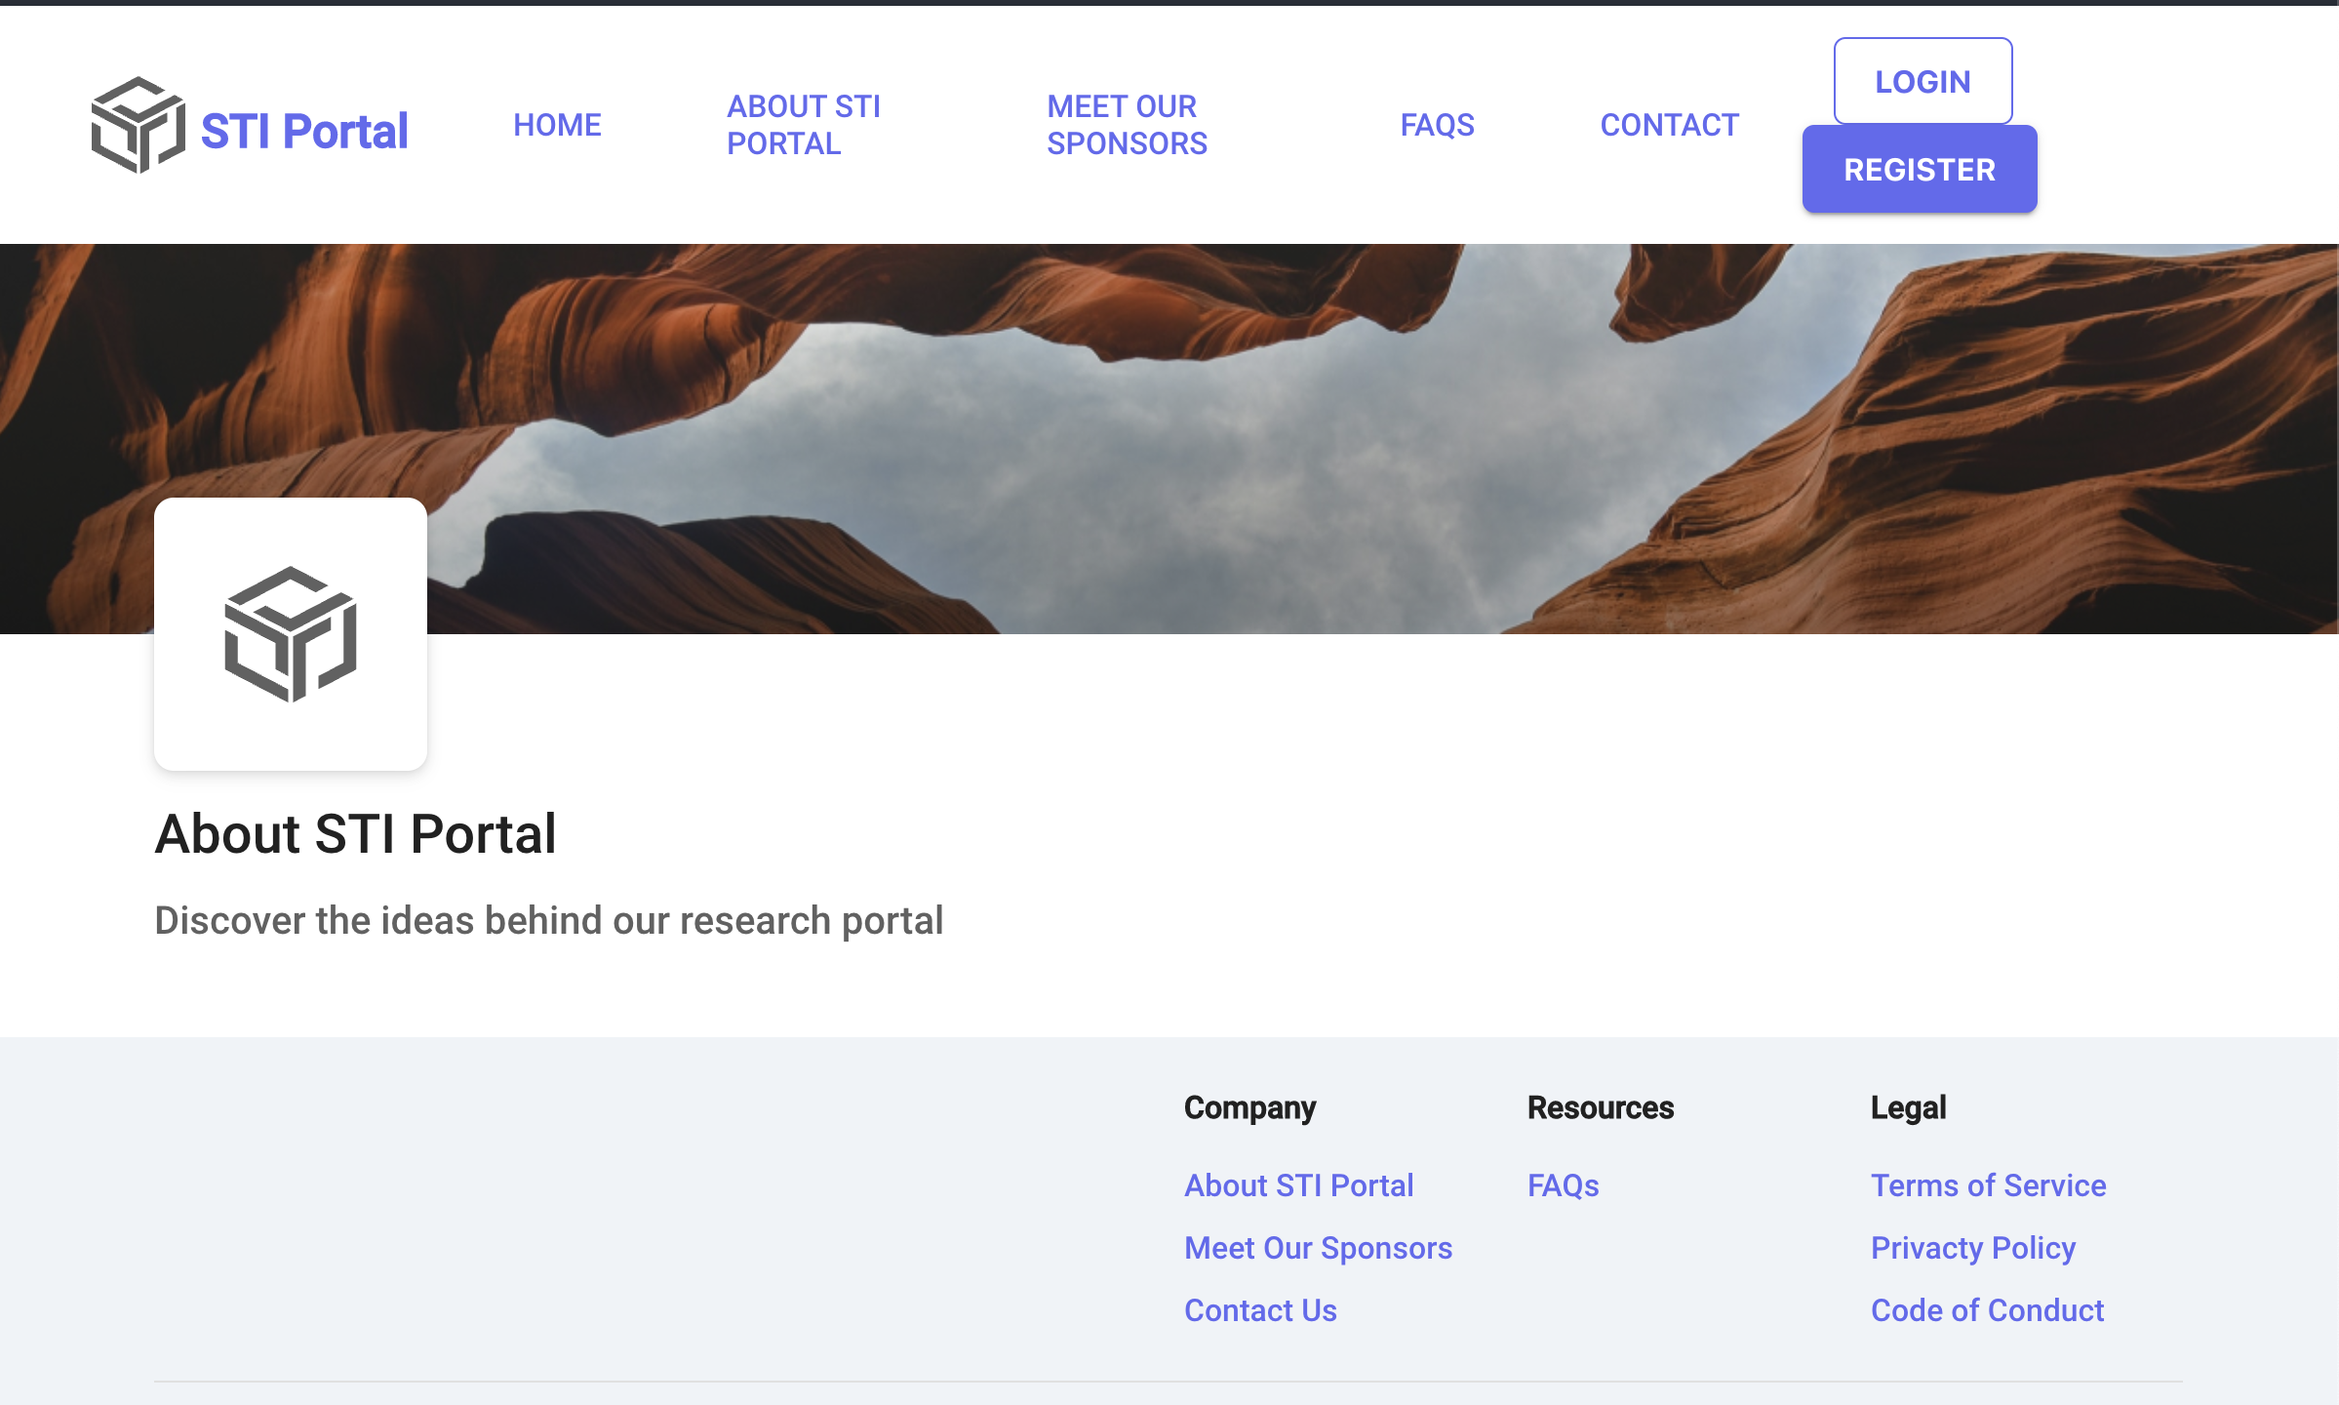

* I think you should change it to ASTI because there are other portals in Asia etc with similar names. And the little logo should have something of Africa to distinguish it from others.
* The text under ‘About the ASTI Portal’ should be:  
    
  The African Science, Technology and Innovation Portal is a South African initiative of the Department of Science and Innovation (DSI) and the National Research Foundation (NRF). It brings together statistics on science, technology and innovation from the African continent and it compares those with other countries in the world.

Through this portal researchers and policy makers alike will find information for relevant and well-informed decisions.

* 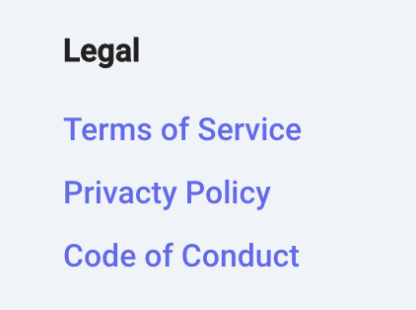Privacy (check spelling)
* ______________

@2022 ASTI Portal. All rights reserved



Department of Science and Technology is one of the departments in the Ministry of Higher Education and Innovation. The Department drives the Science, Technology and Innovation agenda of South Africa. For more information: [www.dsi.gov.za](http://www.dsi.gov.za)

National Research Foundation. The NRF is an independent statutory body. As a government mandated research and science development agency the NRF funds research, the development of high-end Human Capacity and critical research infrastructure to promote knowledge production across all disciplinary fields. For more information: [www.nrf.ac.za](http://www.nrf.ac.za)



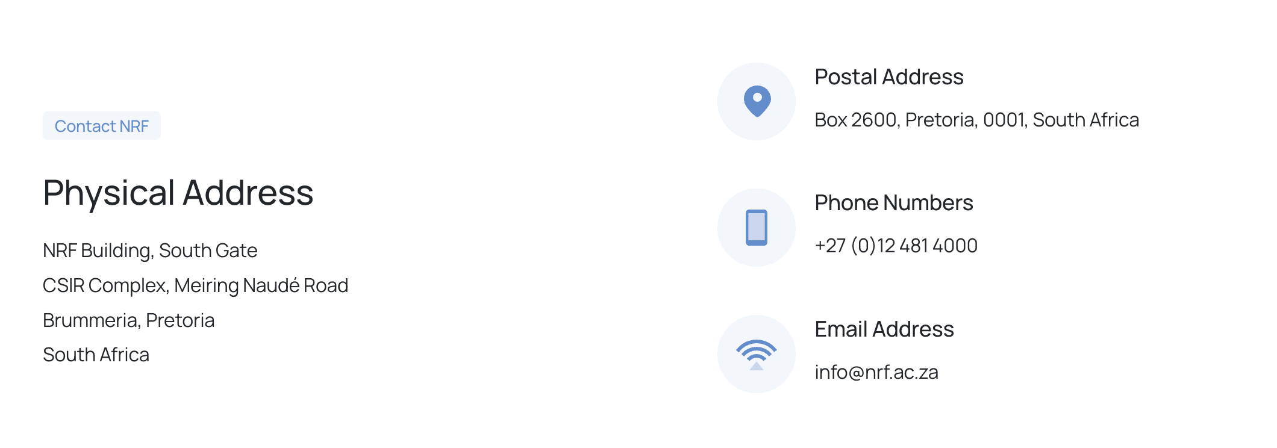

|  |
| --- |
| Coordinates:  -25.756629, 28.276592 |

|  |  |
| --- | --- |
| **Operating Hours** | 08:00 - 16:00 (Monday to Friday) |

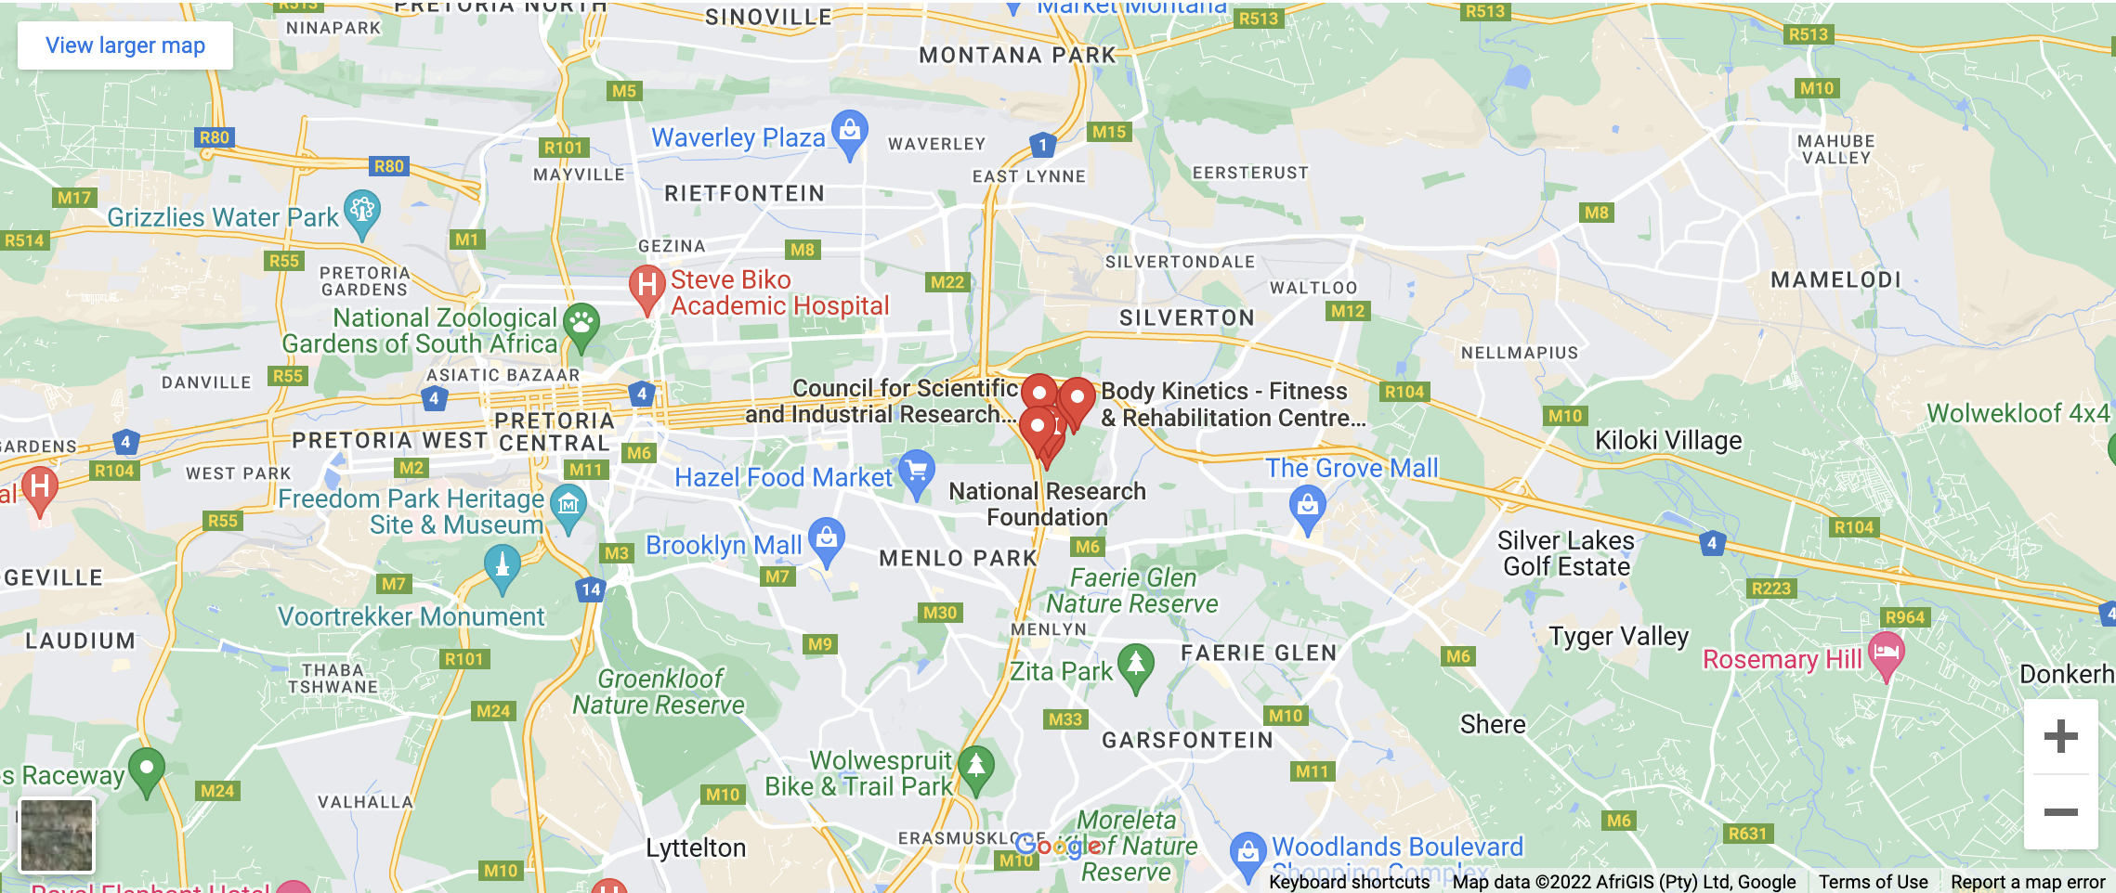

You can take this from Googlemaps

Perhaps we can have here a way of sending a msg to the Portal by entering name, affiliation and topic/question

­­­­­

Disclaimer

The Protection of Personal Information Act, 2013 (POPIA),  came into full effect on 1 July 2021.

The purpose of POPIA is to enhance the constitutional right to privacy by ensuring the collection, storage, protection and distribution of the personal information obtained and processed by public and private bodies is done lawfully.

The privacy of those accessing the ASTI Portal online services, is important to us. In ensuring compliance, we are committed to protecting all personal information provided by you or collected from a third party against misuse, loss, unauthorised access, modification, or disclosure.

Your information will continue to be handled in the right way for the right reasons.

Privacy Policy – If the site is operated by NRF staff and hosted there then the Policy should be as follows

###### 1. PARTIES AND USER ACCESS

###### 

1. The terms and conditions governing access to and use of NRF online content and the NRF website set out herein constitute an agreement between the National Research Foundation (“NRF”) as the owner of the online content, and any person accessing and using such content and website (“the User”).
2. The use of and access to online content will at all times be governed by the provisions of this agreement.
3. By using and/or accessing NRF online content, the User accepts the terms and conditions and agrees to bound by and comply fully therewith.
4. If the User does not wish to be bound by and comply with these terms and conditions in full, the access and use of this website must be terminated immediately.

###### 

###### 2. PRIVACY POLICY

###### 

The NRF is committed to ensuring the privacy and integrity of information submitted by users. As such, the NRF prioritises the protection of all personal information provided to or collected from a third party from misuse, loss, unauthorised access, modification, or disclosure. All information of a personal nature submitted or provided by users will be treated confidentially and will not be disclosed to any person without the express consent of the User concerned subject to the following:

1. The information which is in the public domain shall not be treated as confidential;
2. The confidentiality undertakings made herein shall not apply to information which the NRF is obligated in terms of any law, order of the court, legal process, or other lawful reason to disclose;
3. Personal information may be disclosed to key NRF stakeholders where this information is necessary for them to evaluate and enhance the products and services offered or for statutory reporting purposes;
4. The NRF may disclose specific personal information of users such as names and e-mail addresses to affiliated service providers for purposes of distributing promotional materials, surveys and questionnaires or other information or material for which a User has specifically indicated its willingness to participate;
5. The NRF may provide general information to third parties which do not contain particular personal information of Users, intended to be used solely for statistical and reporting purposes.

###### 

###### 3. COOKIES

###### 

The NRF cannot control the confidentiality, access to or dissemination of information retrieved through the use of “cookies” or information retrieved through the collecting and storing of IP addresses of visitors to this website.

Note:

1. A “cookie” is a computer file transferred automatically from a website to a User’s computer during an online session. Cookies enable the website owner and its sponsors and advertisers to customise webpage content and gather general information on the use and frequency of the user traffic.
2. An IP address is an address assigned to a computer or server identifying it when conducting Internet activity.

###### 

###### 4. COPYRIGHT AND TRADEMARKS

###### 

1. Access to NRF online content does not transfer any rights concerning the intellectual property of the NRF about trademarks, copyright, designs, patents, domain names, know-how, confidential information, trade secrets or any other intellectual property rights which may vest in the NRF or  the authors, compilers, creators, or licensors of such information;
2. All NRF trademarks, logos, brands, domain names and other marks and related intellectual property or any information contained or accessible from NRF online content shall remain the sole and exclusive property of the NRF and the relevant authors or licensors.
3. Users shall not use, disseminate, or otherwise deal with such intellectual property without the express prior written permission of the NRF;
4. Copyright and all other intellectual property rights subsisting in any database/s maintained by the NRF and relating to the online services are owned by the NRF or the relevant provider or supplier thereof;
5. A User may only use information retrieved, viewed, downloaded, or otherwise obtained from NRF online content, for personal, non-commercial purposes.  Such information and/or data may not be sold, resold, transmitted or otherwise made available or disseminated in any manner via any media to any third parties unless the prior written consent of the NRF has been obtained;
6. The User undertakes not to change or delete any proprietary notices contained in any material, data or information downloaded or otherwise retrieved;
7. A User may not reverse engineer, disassemble, decompile, reproduce, transcribe, translate into any language or computer language, retransmitted in any form or by any means (electrical, mechanical, photo reproduction, recordation or otherwise) any of the material, information, or content viewed, downloaded, or otherwise retrieved without the prior written consent of the NRF.

###### 

###### 5. CONTENT ON THIS WEBSITE

###### 

NRF online content is presented for information purposes only unless otherwise advised.  Any health-related information contained herein is not intended to be instructional or for medical diagnosis or treatment. Any medical information shared herein is not intended to replace or substitute professional medical advice and is merely provided for general informational and educational purposes. The information does not relate to any particular individual or individuals. Under no circumstances should any User rely on the information for any treatment and/or medical advice with specific reference to the National Research Facility called iThemba LABS.

###### 6. WARRANTY

###### 

The NRF makes a reasonable effort to keep the NRF online content updated, complete and accurate, but does not warrant or represent that the information is always updated and correct, therefore, the onus lies on the User to verify any information before use. A The NRF does not warrant that this website is uninterrupted, virus- and default-free. It is the responsibility of the User to ensure that his/her device, hardware and/or software are compatible with this website Accordingly, all information viewed or services used or accessed are provided “as is” without any warranty, whether expressed or implied. The NRF does not warrant, hold out, or make any representations about  any services, benefits or facilities offered on this website to Users or a class of Users. Users are cautioned against relying on any service or facility provided and should always independently verify any information or confirmation contained or generated from this website or any software associated therewith.

###### 7. CONTENTS FROM OTHER WEBSITES

###### 

1. All Users accessing the NRF grants management portal must be registered with ORCiD (www.ORCiD.org) for integration purposes;
2. This is required to create and maintain a registry of unique researcher identifiers and a transparent method of linking research activities and outputs to these identifiers;
3. Linking the ORCiD identifier to institutional systems minimises the effort from institutions and researchers and ensures the integrity of system content;
4. The identifier mentioned earlier must be provided to the NRF by the User within the acceptance of the Agreement;
5. The User as a result of this, permits the NRF to process, collect, receive, record, organise, collate, store, update, modify, retrieve, alter, consult, use, disseminate, distribute, merge, link, erase, share or destroy personal information under the Protection of Personal Information Act, 2013 while utilising ORCiD or other related uploads.

###### 

###### 8. HYPERTEXT LINKS AND ADVERTISING

###### 

1. The NRF may provide hypertext links to websites on the World Wide Web which third parties operate;
2. Users are encouraged to use discretion when searching or accessing such links;
3. Under no circumstances does the NRF take responsibility for the content and/or services or products offered on third party websites which may be linked to this website, and gives no warranty, guarantee, and makes no representation in respect of such linked websites;
4. The provisions of these terms and conditions do not apply to such third-party websites which are not under the control of the NRF;
5. Unless specifically indicated in writing, the NRF does not endorse any product whose services are advertised or promoted by advertisement, nor does the NRF make any representation or give any warranty regarding the content, accuracy, suitability or fitness for the purpose of any material, information or data contained in or linked to any advertisement on third party websites.

###### 

###### 9. USER RESTRICTIONS AND SECURITY

###### 

1. The User undertakes to conform to generally acceptable etiquette and to abide by all NRF and DSI operating policies, which may be amended from time to time at the NRF’s discretion;
2. The User warrants and undertakes that all information, documentation, data and material provided or transmitted to the NRF is accurate, truthful and current and that the User is solely responsible for the content, information, documentation, data, and material so provided;
3. The NRF reserves the right to take any action in the law applicable to any documentation, information, data or material which the NRF may in its sole discretion deem necessarily appropriate if it believes that failure to take such action may create any liability whether perceived or otherwise for the NRF or its stakeholders, or against advertisers who cause the NRF to lose or suffer any harm or damages in any proprietary interest or goodwill, or against any conduct which may adversely affect the provision or access to this website or the services of any of its service providers. In particular, the User undertakes:
4. not to violate the privacy of any person;
5. not to violate the security of any computer system or network, which shall include but not be limited to infringing, directly or indirectly, on any copyright, patent, trademark, trade secret or any other proprietary rights or rights to publicity or privacy;
6. not to violate any law, statute, ordinance, regulation or public policy in force in South Africa. In this regard, the User undertakes to familiarise themselves with and ensure that they are kept continuously aware of any amendments to such laws or regulations which may be in force from time to time;
7. to ensure that any information, documentation, data or material submitted or provided to the NRF shall not be defamatory, trade libellous, unlawfully threatening or unlawfully harassing, obscene, offensive or in bad taste;
8. to ensure that any files transmitted shall not contain any “viruses”, “Trojan Horses”, “worms”, “time bombs”, “cancelbots” or any other computer programming routines or software that is intended to damage, detrimentally interfere with, intercept or expropriate any system, data or computer network nor to engage any activities which can be regarded as hacking or otherwise interfering with the integrity of this website and its supporting infrastructure;
9. not to commit any act or any omission which may have adverse technical effects on the integrity or functionality of this website and its supporting servers and infrastructure;
10. not to give or make available in any way the User’s username and password to any other person in any manner for such person’s use, and the User undertakes to take whatever steps may be necessary to ensure the safekeeping and confidentiality of such username and password, and in any event, a User shall not disclose same to any third party without the NRF’s prior written consent;
11. to be legally bound by and held responsible for actions taken with its username and password;
12. to hereby acknowledge that the NRF is entitled to reasonably presume that the User is the transacting party where a specific username and password has been used to gain access to, view and/or engage in any activity on this website or any part thereof;
13. to immediately notify the NRF should it have any reason to believe that the confidentiality of the username and password may be compromised; and
14. to inform the NRF of any restrictions and/or limitations on the authority of any authorised user who has been given access to the service and/or content of this website promptly and in writing.

###### 

###### 10. DISCLAIMER AND INDEMNITY

###### 

1. Due to the number of sources from which the NRF obtains content and the nature of electronic distribution via the World Wide Web (WWW), neither the NRF nor any of its suppliers shall be liable to any User or any other person in respect of any loss or damage of whatsoever nature caused by or arising from any of the following circumstances. The User hereby indemnifies the NRF and its suppliers against all claims in respect of such loss or damage:
2. resulting from or related to the use or access of or inability to use or access any of the information, content or services provided on this website;
3. any fact or circumstance beyond the reasonable control of the NRF;
4. any breakdown in the service provided by external service providers;
5. the performance or unavailability of online content, or any other website to which it is connected or linked;
6. any suspension or interruption of access to this website by the NRF;
7. any breach of privacy or security by any person or entity the loss, damage, destruction, theft, contamination or corruption of any data, information or content accessed through this website the preservation and protection of the integrity of any text or any other form of data, information or content which is contained on or accessible from this website;
8. any publication or use of any information or data contained on or accessible from this website;
9. User’s failure to perform any of its obligations in terms of this agreement, including but not limited to a failure to comply with any of the provisions of clause 9.
10. Without limiting the generality of the preceding, neither the NRF nor its suppliers shall be liable for any direct, consequential or indirect loss suffered by a User or any other person. The User hereby indemnifies and holds the NRF and its suppliers harmless against any such claim or liability, including but not limited to loss of profits, loss of data and/or loss of anticipated business or goodwill.
11. While the NRF will use all reasonable endeavours to ensure integrity, security and confidentiality of all personal information submitted and/or obtained from a user, it will not be held liable under any circumstances if such information is compromised, disseminated or otherwise disclosed through conduct outside the control of the NRF such as hacking, infection by viruses, Trojan Horses or any other computer programming routines or software that are intended to damage, detrimentally interfere with, surreptitiously intercept or expropriate any system, data or personal information.
12. The NRF hereby disclaims any liability for, and the User hereby indemnifies the NRF and its suppliers from and against, all losses, liability, costs or damage suffered or incurred by a User or any other person arising out of or in connection with the use, provision or distribution of any feature or service which may be promoted, displayed on, or associated with, this website or any other website which can be accessed from this website. However, such loss or liability may occur, and whether such loss or harm is financial, personal, consequential, incidental or otherwise.
13. The NRF does not warrant or represent that the functions, facilities or services or content contained on this website, or access to this website or any part thereof, will be uninterrupted or error-free, that defects will be corrected, or that this website and/or the server that makes it available to a User, are free of viruses, infections, bugs or the like, nor does the NRF make any warranty or representation, whether express or implied, as to the reliability, accuracy, usefulness, adequacy, quality, currency, completeness, suitability, fitness for any purpose or otherwise of any of the information, services, facilities, data or material displayed on or accessed from this website.

###### 11. ONLINE COMMUNICATIONS

1. Where any user is permitted to participate in online communications such as sending and receiving electronic mail (e-mail), engaging in conferences, downloading and uploading files, and another use permitted by the NRF, such access and participation is subject to the following:
2. files that may be uploaded, public messages sent and the User’s activity in conferences are subject to review, modification and deletion without notice by the representative of the NRF responsible for the administration in the area where the action takes place;
3. the NRF’s operating policy relating to online conduct, storage and deletion of e-mail and uploading files, conferences, bulletin boards and other matters are available and/or will be made available online. The NRF reserves the right in its sole discretion to change such policies at any time and from time to time;
4. files uploaded to a bulletin board may be subject to posted limitations on usage, reproduction and dissemination and users are responsible for adhering to such limitations should they download same.
5. Users are expressly prohibited from engaging in any of the following activities:
6. Posting or transmission of any message which is or is likely to be interpreted as libellous, harmful, threatening, abusive or defamatory in the opinion of the NRF;
7. ii.Posting or transmission of any message, data, image or program which is indecent, obscene or pornographic;
8. iii.Posting the same note more than once (“spamming”) is strictly prohibited;
9. iv.Interception or attempted interception of e-mail or other private communications not intended for that User;
10. v.Use of this website as a mass unsolicited distribution medium to communicate a generally unsolicited message; and
11. vi.Sending unsolicited e-mail messages through third party mail service to relay, hide the origin of the e-mail to others;
12. A User’s participation in online communication occurs in real-time and is not edited, censored or otherwise controlled by the NRF. The NRF cannot and does not screen content provided by Users during online communication. Notwithstanding the preceding, the NRF reserves the right to monitor and record content in online communications but is not obliged to do so. The NRF reserves the right to remove content which the NRF in its sole discretion determines to be harmful, offensive or otherwise in violation of these terms and conditions or the NRF’s operating policies for users on the NRF online.

###### 12. SUSPENSION AND TERMINATION

* a.Suppose the User user should engage in any one or more of the prohibited practices or fail to comply with any obligations contemplated in clause 9, or otherwise breach any of the provisions of these terms and conditions, which shall be determined in the NRF’s sole discretion and which decision shall be final. In that case, the NRF shall be entitled to, without prejudice to any of its rights to:
* i.terminate or suspend, without notice, the User’s access to or use of this website or any service or facility;
* ii.charge the User for any costs incurred by the NRF, including, but not limited to, administration costs and downtime; and
* iii.if any such practice has an adverse technical effect on the network, to require the User to take such steps as may be necessary to rectify the situation at their own cost and expense.
* iv.The termination or suspension of a User’s right to use or access this website or any part thereof will not affect the provisions of these terms and conditions, which shall survive any such termination or suspension.

###### 13. NOTICES

a.The NRF may deliver notice to the User under these terms and conditions using electronic mail, a general notice on this website, or by written communication delivered by registered post to the User’s address on record. A user may give notice to the NRF at any time via electronic mail at:

[info@nrf.ac.za](mailto:info@nrf.ac.za)  or by registered mail to the following address:

NRF, PO Box 2600, Pretoria 0001, South Africa.

1. An e-mail duly transmitted by either party shall be deemed to have been received 1 (one) day after the date of transmission provided that no notice has been received indicating a failure of or inability to deliver such message. Correspondence sent by registered mail shall be deemed to have been delivered 10 (ten) days after the date of posting.

###### 14.THIRD-PARTY RIGHTS

The provisions of these terms and conditions are stipulated for the benefit of the NRF, its officers, directors, employees, agents, licensors, suppliers and information providers. Each of these persons or entities shall have the right to assert or enforce any of these provisions directly against the User on its own instance, and the aforementioned persons or entities hereby accepts such stipulation.

###### 15. LAW TO APPLY

1. The provisions of these terms and conditions shall be governed and construed under the laws of the Republic of South Africa;
2. The law requires that any action related to a transaction be carried out in writing or using a paper document. That requirement shall be met if the activity is carried out in an electronic format or using a data message (including but not limited to e-mail ).

###### 16. WHOLE AGREEMENT

These terms and conditions constitute the whole agreement between the parties, and any undertakings shall bind no party, representations, warranties, promises or the like not recorded herein.

###### 17. NO WAIVER

Failure or neglect by the NRF to fully enforce at any time any of its rights or any of the provisions of this agreement shall not be construed as a waiver of its rights, nor shall such failure or neglect in any way act as estoppel or effect the validity of the whole or any part of these terms and conditions, nor prejudice the NRF’s rights to take any action which may have arisen in the past or which may occur in the future.

###### 18. VARIATION

1. The NRF reserves the right to change the content, presentation, format, performance, layout, facilities and services available or displayed on this website or any part thereof at its sole discretion and hereby disclaim all liability for any losses, claims, damages or inconvenience which any person may suffer as a result of such changes;
2. The NRF may modify these terms and conditions at any time, and such modification shall be effective immediately on the posting of such amendment or modification on this website. A User may request e-mail notification of such revisions or changes by contacting the NRF at [info@nrf.ac.za](mailto:info@nrf.ac.za);
3. It is the responsibility of all Users to ensure that they are aware of any modifications and/or updates or changes;
4. The continued use by a User or access to or viewing of this website and or the services offered shall be deemed conclusive acceptance of such modified terms and conditions.

###### 19. SEVERABILITY

Suppose any of the terms of this Agreement are found to be invalid, unlawful or unenforceable. In that case, such terms will be separable from the remaining terms, which shall continue to be valid and enforceable.

###### 20.CESSION AND DELEGATION

1. The User shall not cede any of their rights nor delegate any of their obligations in terms of these terms and conditions;
2. The NRF shall be entitled to cede and transfer or delegate to any third party at its absolute discretion all or any of its rights or obligations under these terms and conditions.

###### 21. SPECIFIC TERMS OF USE

If any specific terms of use appearing on this website regarding all or a portion of the content displayed on or accessible from this website, which specific terms of use conflict with any of these terms and conditions, then the specific terms shall prevail regarding such content.